Analysis of a Peptide Sequence from a Proteolytic Digest by MALDI-TOF
Post-Source Decay (PSD) and Collision-Induced Dissociation (CID)
Standard Operating Procedure

Purpose:

The following procedure may be used to gather sequence data of peptides resulting from the complete or partial proteolytic digestion of a protein sample. This procedure employs post-source decay (PSD) and collision-induced ionization (CID) techniques of matrix-assisted laser-desorption ionization time-of-flight (MALDI-TOF) mass spectrometry, and is specific to the Voyager Biospectrometry Workstation. Refer to the Voyager V5.1 User’s Guide and Data Explorer V4 User’s Guide, included with the Voyager software package, for complete specifications of the Voyager Biospectrometry Workstation.

Procedure:

- Prepare the MALDI sample plate by spotting an angiotensin standard and the test sample(s).

Dilute the angiotensin standard (stock concentration = 50 µmol/mL) by a factor of 25 in matrix for a final ideal concentration of 2 µmol/mL. Also, dilute the test sample accordingly to reach a final concentration near this value. Higher concentrations may suppress fragment ion formation and decrease the quality of the resulting data.

The Voyager instrument is equipped with a deflector gate for the purpose of precursor ion selection. This means that it is possible for the instrument to gather PSD fragment data of a single precursor peptide contained in a mixture of peptides (such as a raw digest). However, it is strongly advised that the peptide(s) of interest be purified from the mixture prior to PSD analysis, to optimize signal quality.

Load the sample plate into the instrument and turn on high voltage.

- Acquire angiotensin precursor ion external calibration data.

2.1 Load the angiotensin_precursor.bic instrument settings file.

2.2 Under Data Storage, select the directory into which the precursor spectrum will be saved.

2.3 Enter a filename for the angiotensin precursor ion spectrum (e.g. angiotensin_precursor.dat).

2.4 Under Calibration, select from the pull-down menu the correct matrix that was used to spot the angiotensin standard.

2.5 Below the matrix menu, select Default for the external calibration.

2.6 Acquire a precursor ion spectrum of the angiotensin sample. A peak distribution at 1296.7 Da should predominate. Save this spectrum.

2.7 Open angiotensin_precursor.dat in Data Explorer (Figure 1).

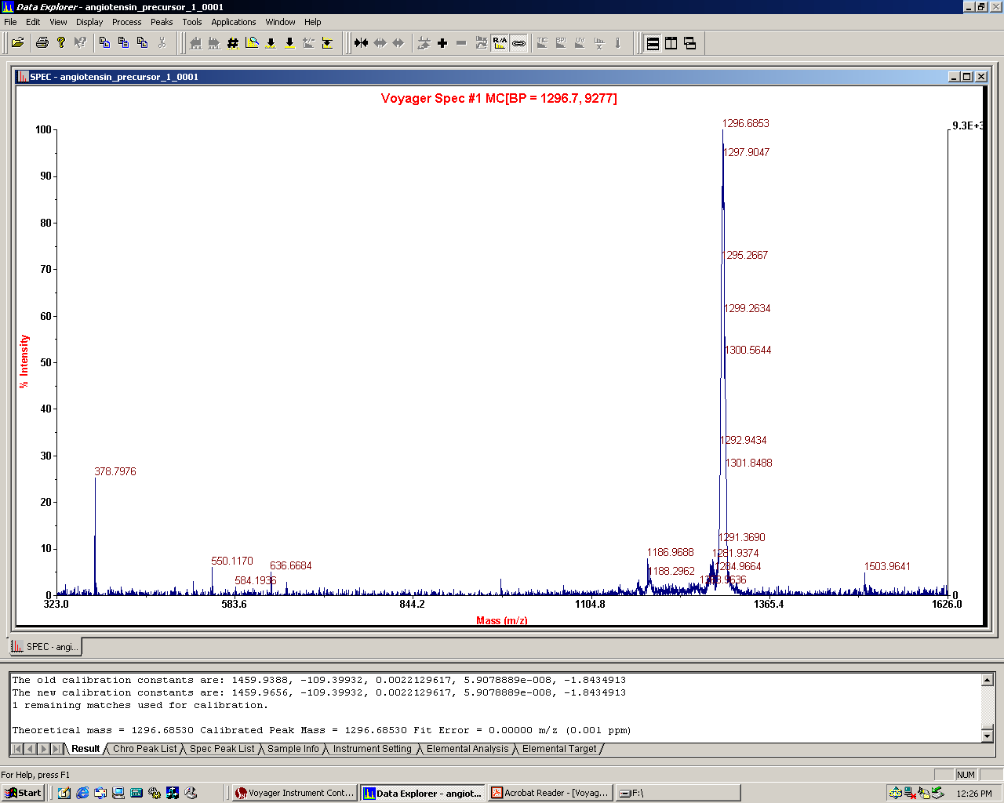
Precursor ion
Fragment ions

Figure 1: Precursor ion spectrum of angiotensin.

2.8 Optimize the raw spectrum by selecting Process → Centroiding.

2.9 Go to Process → Mass Calibration → Manual Calibration (Figure 2). Select C:\voyager\voyager.ref as the reference file and then select Match Peaks.

The centroid peak near 1296.7 Da should be found. If not, the search tolerances may need to be widened slightly. Since the precursor ion calibration is a single-point calibration, delete any found peaks other than the correct precursor ion peak from the list.

Confirm that the found peak is the correct precursor ion peak, and then select Plot. The calibration will be applied to the spectrum for review.

2.10 Select Apply Calibration to finalize the calibration changes.

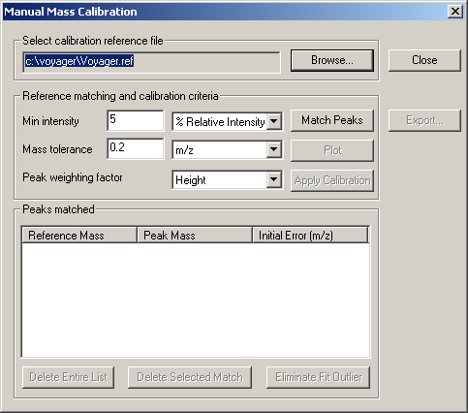

Figure 2: Manual Mass Calibration dialog box

2.11 While still in the Manual Calibration window, select Export… and then specify a filename for the angiotensin precursor ion calibration file (e.g. angiotensin_precursor.cal).

This will save the calibration constants for the angiotensin precursor ion, to be used as an external single-point calibration for the precursor ion mass in the PSD spectrum.

- Acquire angiotensin PSD fragment calibration data.

3.1 Load the angiotensin_PSD.bic instrument settings file.

3.2 Under Data Storage, select the directory into which the PSD data will be saved.

3.3 Enter a filename for the angiotensin PSD calibration spectrum (e.g. angiotensin_PSD.dat).

3.4 Under Calibration, select from the pull-down menu the correct matrix that was used to spot the angiotensin standard.

3.5 Below the matrix menu, select the angiotensin_precursor.cal external calibration file that was generated.

3.6 In the PSD settings window, enter “1296.68” for the Precursor Mass. This sets the timed deflector gate to only allow fragments from precursor ions of approximately 1296.68 Da to pass.

3.7 Under PSD Calibration, select Default.

3.8 Acquire a spectrum for the first segment (Mirror Ratio = 1.000) of the PSD spectrum.

The PSD spectrum itself is a composite spectrum of several spectra taken at differing mirror ratios. The mirror ratio for each segment is a fraction of that of the prior segment, called the decrement ratio. The mirror ratio is optimized to accurately obtain only a narrow range of mass values, and so for a wide range of mass values to be determined in the PSD spectrum, separate spectra must be taken over a range of decreasing mirror ratios, and then “stitched” or averaged together to form a composite spectrum. Vertical scale values are a scalar function for each segment. A lower vertical scale results in a more heavily weighted intensity in the composite spectrum.

Once the spectrum for the first segment has been saved, the PSD experiment has been initiated, and all subsequent spectra can be stitched into the specified PSD spectrum file (angiotensin_PSD.dat). No instrument settings can be changed at this point. In order to end the experiment, select Stop Experiment from the taskbar at the top of the window. Once stopped, all PSD segments will be stitched into the composite PSD spectrum, and no additional segments can be added later. Make sure all instrument settings are correct before acquiring and saving the first PSD segment spectrum.

When satisfied with the spectrum, select Save Spectrum from the taskbar at the top of the window, next to the Acquire Spectrum option.

3.9 Acquire spectra for each subsequent mirror ratio. When satisfied with each spectrum, select Save Spectrum from the taskbar at the top of the window before moving on to the next segment.

For each successive segment, more energy will be required to fragment the peptide into smaller ions. Increase the laser intensity about 50 – 150 counts for each lower mirror ratio. At very small mirror ratios, the intensity may need to be dropped in order to observe very small ions which are easily fragmented from the peptide. If the sample amount allows, it is best to optimize the laser intensity for each segment before saving into the PSD spectrum.

3.10 When spectra for all PSD segments have been obtained and saved to the PSD spectrum, select Stop Experiment from the taskbar at the top of the window.

  - Open angiotensin_PSD.dat in Data Explorer (Figure 3).

3.12 Optimize the raw spectrum by selecting Process → Baseline Correction. If desired, use noise filtering/smoothing or centroiding to further optimize resolution of ion fragment peaks.

3.13 Go to Process → Mass Calibration → PSD Calibration. Select C:\voyager\angiotensin_fragments.ref as the reference file and then select Match Peaks. A list of peaks in the individual segment spectra should be found. “Duplicate” peaks are actually corresponding peaks found at different mirror ratios (in different segment spectra). A list of major fragment ion peaks in the angiotensin PSD spectrum is given in Table 1. Review matched peaks and then select Plot. The calibration will be applied to the spectrum for review.

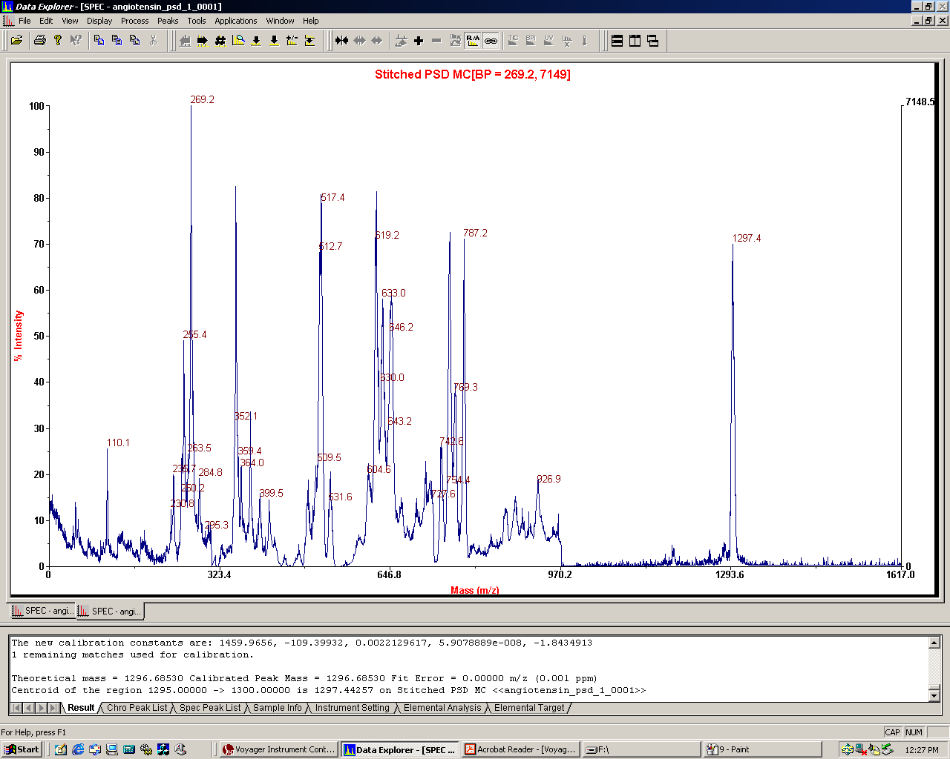
Precursor ion
Fragment ions

Figure 3: PSD spectrum of angiotensin.

3.14 Select Apply Calibration to finalize the calibration changes.

3.15 While still in the PSD Calibration window, select Export… and then specify a filename for the angiotensin PSD fragment ion calibration file (e.g. angiotensin_PSD.cal).

This will save the calibration constants for the angiotensin PSD fragment ions, to be used as an external multi-point calibration for PSD analysis of a peptide.

Table 1: Major fragment ions in angiotensin PSD spectrum

Expected Mass (Da) | Fragment Ion
110.08 | His (immonium)
255.16 | b2 – 17 (–NH₃)
269.16 | y2
354.20 | b3 – 17 (–NH₃)
513.08 | y4
619.36 | a5
784.41 | b6
1181.6 | y9

4. Acquire peptide precursor ion calibration data.

  - Load the peptide_precursor.bic instrument settings file.

4.2 Under Data Storage, select the directory into which the precursor spectrum will be saved.

4.3 Enter a filename for the peptide precursor ion spectrum (e.g. peptide_1_precursor.dat).

4.4 Under Calibration, select from the pull-down menu the correct matrix that was used to spot the peptide sample.

4.5 Below the matrix menu, select Default for the external calibration.

4.6 Acquire a precursor ion spectrum of the peptide sample.

Adjust laser intensity to optimize the precursor ion signal.

This procedure assumes that an accurate mass has already been determined for the peptide of interest using reflector mode high-resolution analysis. This precursor ion spectrum will be used to generate a single-point external calibration for the peptide precursor ion, to be used in PSD analysis. In order to generate this calibration data, a precursor ion reference file must be created which contains the accurate mass of the peptide.

When a good precursor ion spectrum has been obtained, save the spectrum to the specified data file.

4.7 Open the saved spectrum (peptide_1_precursor.dat) in Data Explorer.

4.8 Optimize the raw spectrum by selecting Process → Centroiding.

4.9 Generate a reference file for the peptide precursor ion.

4.9.1 Go to Process → Mass Calibration → Edit/Create Reference File. The Edit/Create Reference Peak Information dialog box (Figure 4) is displayed.

Figure 4: Edit/Create Reference Peak Information dialog box

4.9.2 Enter the Name (e.g. Peptide_1) and Theoretical m/z value (obtained from high-resolution analysis) for the peptide precursor ion. Also select the charge state of the ion.

4.9.3 Enter Resolved Isotope Mass as the mass type, unless otherwise instructed.

4.9.4 Select Insert.

4.9.5 If creating a reference file for more than one precursor ion (such as a single file for all peptide fragments of a protein), repeat steps 4.9.2 – 4.9.4 for all remaining ions of interest.

4.9.6 To modify an existing value, select the mass from the list, enter updated values, then select Update.

4.9.7 Select Save to save all data to a new reference file. In the Save As dialog box, select a location and name for the new reference file (e.g. peptide_1_precursor.ref).

4.10 Go to Process → Mass Calibration → Manual Calibration. For the reference file, select the directory and filename of the precursor ion reference file that was generated, and then select Match Peaks.

The centroid precursor ion peak should be found. If not, the search tolerances may need to be widened slightly. Since the precursor ion calibration is a single-point calibration, delete any found peaks other than the correct precursor ion peak from the list.

Confirm that the found peak is the correct precursor ion peak, and then select Plot. The calibration will be applied to the spectrum for review.

4.11 Select Apply Calibration to finalize the calibration changes.

4.12 While still in the Manual Calibration window, select Export… and then specify a filename for the peptide precursor ion calibration file (e.g. peptide_1_precursor.cal).

This will save the calibration constants for the peptide precursor ion, to be used as an external single-point calibration for the precursor ion mass in the PSD spectrum.

- Acquire peptide PSD fragment data using peptide precursor calibration data and angiotensin PSD fragment calibration data.

5.1 Load the peptide_PSD.bic instrument settings file.

5.2 Under Data Storage, select the directory into which the PSD data will be saved.

5.3 Enter a filename for the peptide PSD calibration spectrum (e.g. peptide_1_PSD.dat).

5.4 Under Calibration, select from the pull-down menu the correct matrix that was used to spot the peptide sample.

5.5 Below the matrix menu, select the peptide precursor ion single-point external calibration file that was generated (peptide_1_precursor.cal).

5.6 In the PSD settings window, enter the known accurate mass of the peptide precursor ion for the Precursor Mass. This sets the timed deflector gate to only allow fragments from the peptide precursor ion of interest to pass.

5.7 Under PSD Calibration, select the angiotensin PSD fragment multi-point calibration file that was generated (angiotensin_PSD.cal).

5.8 Acquire a spectrum for the first segment (Mirror Ratio = 1.000) of the PSD spectrum.

Adjust laser intensity to optimize the precursor ion signal.

Once the spectrum for the first segment has been saved, the PSD experiment has been initiated, and all subsequent spectra can be stitched into the specified PSD spectrum file (peptide_1_PSD.dat). No instrument settings can be changed at this point. In order to end the experiment, select Stop Experiment from the taskbar at the top of the window. Once stopped, all PSD segments will be stitched into the composite PSD spectrum, and no additional segments can be added later. Make sure all instrument settings are correct before acquiring and saving the first PSD segment spectrum.

When satisfied with the spectrum, select Save Spectrum from the taskbar at the top of the window, next to the Acquire Spectrum option.

5.9 Acquire spectra for each subsequent mirror ratio. When satisfied with each spectrum, select Save Spectrum from the taskbar at the top of the window before moving on to the next segment.

For each successive segment, more energy will be required to fragment the peptide into smaller ions. Increase the laser intensity about 50 – 150 counts for each lower mirror ratio. At very small mirror ratios, the intensity may need to be dropped in order to observe very small ions which are easily fragmented from the peptide. If the sample amount allows, it is best to optimize the laser intensity for each segment before saving into the PSD spectrum.

5.10 When spectra for all PSD segments have been obtained and saved to the PSD spectrum, select Stop Experiment from the taskbar at the top of the window.

5.11 Open saved PSD spectrum (peptide_1_PSD.dat) in Data Explorer for analysis.

No further calibration is necessary, as the spectra were collected using the previously generated single- and multi-point calibration constants.

If desired, optimize the raw spectrum by selecting Process → Baseline Correction. Use noise filtering/smoothing or centroiding to further optimize resolution of ion fragment peaks.

- Using the fragment calculator to calculate mass fragments of a peptide.

  - Go to Applications → Ion Fragment Calculator (Figure 5).

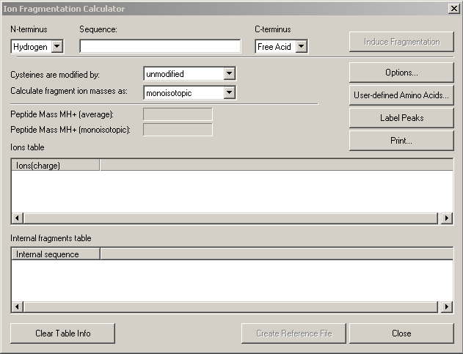

Figure 5: Ion Fragment Calculator dialog box
  - Type the amino acid sequence of the peptide of interest in the Sequence text box using single-letter codes.

  - Select Options to specify which fragment ions to generate, and the tolerances for peak labeling (Figure 6).

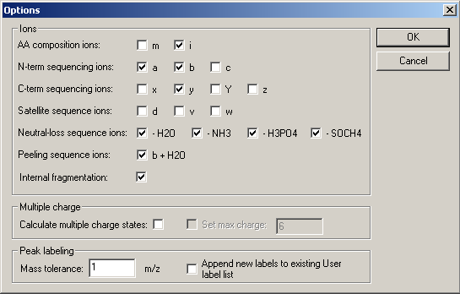

Figure 6: Options for Ion Fragment Calculator dialog box

  - Set other parameters in the Ion Fragment Calculator dialog box as necessary.

6.5 Click Induce Fragmentation to generate all possible fragments under the specified parameters.

  - If desired, click Label Peaks to label all matching peaks within tolerances in the spectrum with their corresponding fragment labels.

- Using the CID function to enhance fragmentation.

Collision-induced dissociation (CID) is a method by which highly energetic species generated at the source are passed through a collision cell containing a low concentration of a collision gas, in this case air, before passing into the flight tube. The collisions between the high energy species and gas molecules result in a larger number of ion fragments generated, enhancing the resulting PSD fragment spectrum. For a more detailed explanation, refer to Section 8.3 in the Voyager V5.1 User’s Guide.

  - Purge collision gas lines.

Before introducing the collision gas, the gas lines must be purged to prevent disruption of the vacuum in the source chamber.

7.1.1 Open the bottom left panel on the front of the Biospectrometry Workstation.

7.1.2 Ensure that BA1 (Source Chamber pressure) on the vacuum gauge (Figure 7) is below 2x10⁻⁷ Torr.

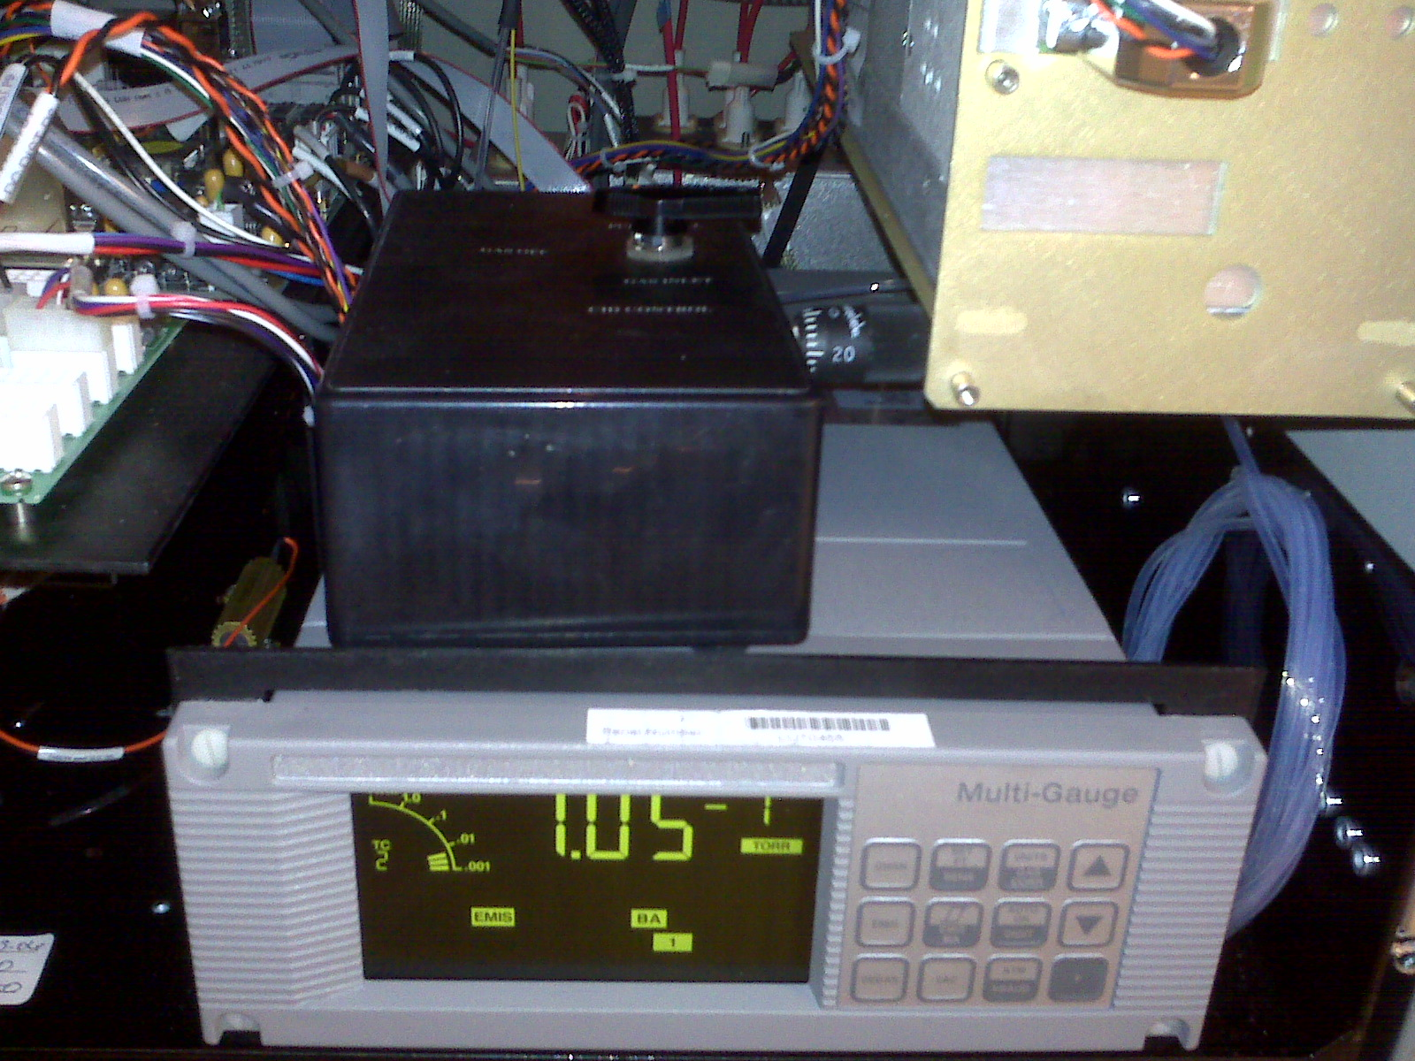

Figure 7: Vacuum gauge and 3-position CID box

7.1.3 Turn the metering valve on the right side of the CID box to zero, then turn it on approximately ¼ turn.

7.1.4 Turn the 3-way valve on the CID box (Figure 7) to the Purge Cell position. Hold for 1 to 2 seconds.

7.1.5 Turn the valve to the Gas Inlet position for 1 second, then turn immediately to the Purge Cell position.

Observe BA1 on the vacuum gauge. The pressure will increase initially, then decrease.

7.1.6 When BA1 decreases to about 1x10⁻⁶ Torr, turn the valve to the Gas Inlet position for 2 seconds, then turn immediately to the Purge Cell position.

Again, BA1 will increase initially then decrease.

7.1.7 When BA1 decreases to about 1x10⁻⁶ Torr, turn the valve to the Gas Inlet position for 3 seconds, then turn immediately to the Purge Cell position.

The lines should now be purged. If BA1 reads greater than 2x10⁻⁶ Torr, repeat step 7.1.7.

7.1.8 Turn the valve to the Gas Inlet position.

7.1.9 If the collision gas is not already turned on, turn the gas on.

7.1.10 Wait 2 minutes for BA1 on the vacuum gauge to stabilize. Once stabilized, adjust the metering valve on the right side of the CID box to obtain the optimum pressure for CID operation (if previously determined).

If increasing the pressure, turn the metering valve to a higher setting and wait for BA1 to stabilize.

If decreasing the pressure, turn the metering valve to a lower setting. Turn the 3-way gas valve to the Purge Cell position, then to the Gas Inlet position. Wait for BA1 to stabilize.

7.2 To use the CID function, perform a PSD experiment as normal (outlined in Sections 2-5) with the collision gas on and the source pressure set to an optimum pressure using the collision gas.

No software settings need to be adjusted to enable CID function. Fragmentation should be noticeably enhanced following introduction of the CID gas into the collision chamber.

7.3 Turning off the collision gas.

7.3.1 Turn the 3-way valve on the CID box to the Purge Cell position.

7.3.2 Wait approximately 20 seconds for the gas to evacuate the collision chamber.

7.3.3 Turn the 3-way valve to the Off position.

